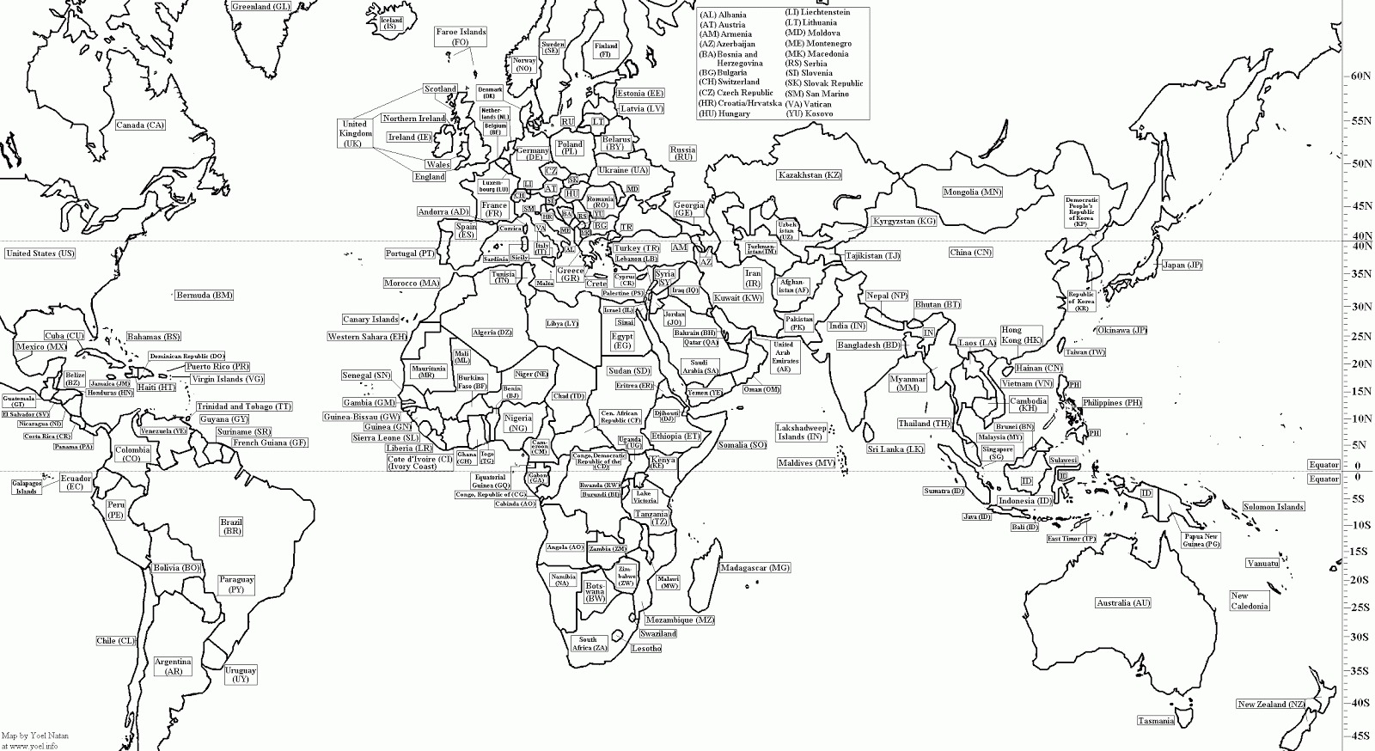
CULTURE CORNER: George Orwell 1984
Activity: pre and post-watching exercises
Age: 16 - 18
Level: B2
Time: 2 lessons
Material: digital projector, worksheets, mobile phones
Outcomes:
• extracting information about George Orwell and his masterpiece 1984
• exchanging information after watching the play
• writing a Newspeak dictionary

INTRODUCTION
STEP 1 – GEORGE ORWELL’S BIOGRAPHY
Students use their mobiles to find out most relevant information about George Orwell’s life and work.
(George Orwell (born Eric Arthur Blair; 1903–1950) was an influential English novelist, essayist, and critic known for his sharp social commentary, lucid prose, and staunch opposition to totalitarianism. Famous for Animal Farm and Nineteen Eighty-Four, he drew on his experiences as a colonial policeman in Burma, a wanderer in poverty, and a Spanish Civil War volunteer.
Key Facts & Life Highlights
Born: June 25, 1903, in Motihari, Bengal, India.
Education: Educated at Eton College in England.
Early Career: Served in the Indian Imperial Police in Burma (1922–1927), an experience that fueled his anti-imperialist views.
Literary Career: Adopted the pen name George Orwell and published Down and Out in Paris and London (1933).
Political Views: A democratic socialist who fought against fascists in the Spanish Civil War.
Major Works: Animal Farm (1945), a satire on Stalinism, and Nineteen Eighty-Four (1949), a dystopian novel on surveillance and truth.
Death: Died of tuberculosis at age 46 on January 21, 1950, in London.
Orwell's work remains highly relevant, with terms like "Orwellian" and "Big Brother" firmly rooted in modern political discourse.)
We brainstormed the influence of his privileged childhood in India, impact of Spanish Civil War, the ideas of Communism and Capitalism and Cold War.

STEP 2 – MAP COLOURING
At the very start of the lesson, we brainstorm surveillance societies and where they exist. To do this, students do this map activity where they colour in a map of the world according to levels of surveillance. They would colour a country black if they thought there were high levels of surveillance, and blue if they thought they were low levels, and then everything in between.

STEP 3 – INTRODUCING NEW VOCABULARY
Students are given flashcards to get familiar to new vocabulary
- zealot (n)- fanatic
“Some nosing zealot in the ministry might start wondering why he had been writing.”
- posterity (n)- future generations
“They were executed, and their fate was recorded in the Party histories, a warning to posterity.”
- bourgeoisie- middle class; common (used as an insult to say that you are boring and common!!)
“They are lackeys of the bourgeoisie! Flunkies of the (negative connotation) ruling class!”
- prevaricate-be deliberately ambiguous or unclear in order to mislead or withhold information
‘’ If you tell me any lies, or attempt to prevaricate in any way, or even fall below your usual level of intelligence, you will cry out with pain, instantly.’’

- premonitory - warning of future misfortune
‘’A sort of premonitory tremor, a fear of he was not certain what, had passed through Winston as soon as he caught his first glimpse of the cage’’
- disseminate-cause to become widely known
‘’He heard himself promising to lie, to steal, to forge, to murder, to encourage drug-taking and prostitution, to disseminate venereal diseases, to throw vitriol in a child's face.’’

STEP 4 – KEY THEMES

Students are divided into four groups and each group discusses one of the following topics providing examples. They present them to the rest of the class.

- Totalitarianism: citizens. The novel portrays a society where the government exerts absolute power over its Surveillance and Privacy: Orwell explores the idea of constant surveillance, symbolized by Big Brother, and how it erodes freedom.
- Propaganda and Truth: The manipulation of truth through the Party’s control of language and history is central to maintaining power.
- Individual vs. Collective: The struggle between individual freedom and the state’s demand for absolute obedience is a major conflict.
- Language and Thought Control: language in controlling reality.

POST – WATCHING ACTIVITIES

STEP 1 – CHECK FOR UNDERSTANDING
Students discuss the questions.
1. What historical leaders used propaganda in ways similar to the Party?
2. How does fear maintain control in both the real world and 1984?
3. Is Orwell’s vision of the future still relevant today?
4. What modern technologies resemble those in 1984?
5. How does Orwell’s message about truth apply in the age of misinformation?
6. How does social media resemble aspects of 1984’s surveillance?
7. Are people today willingly giving up privacy in ways similar to 1984?
8 Should there be limits to how much information the governments or corporations collect?

STEP 2 – CREATIVE WRITING
Students create a mini Newspeak dictionary inventing 5-10 words based on Orwell’s rules, to emphasize how limiting language restricts freedom of thought.

Sources
https://shorturl.at/KAoNu
https://shorturl.at/r9vOO

